**Studio 10**

**Design to Code Traceability II**

Jay Patel

Christian Klein

Joseph Thill

Derek Yu

Zifeng Jiang

**Modified Class Diagram**

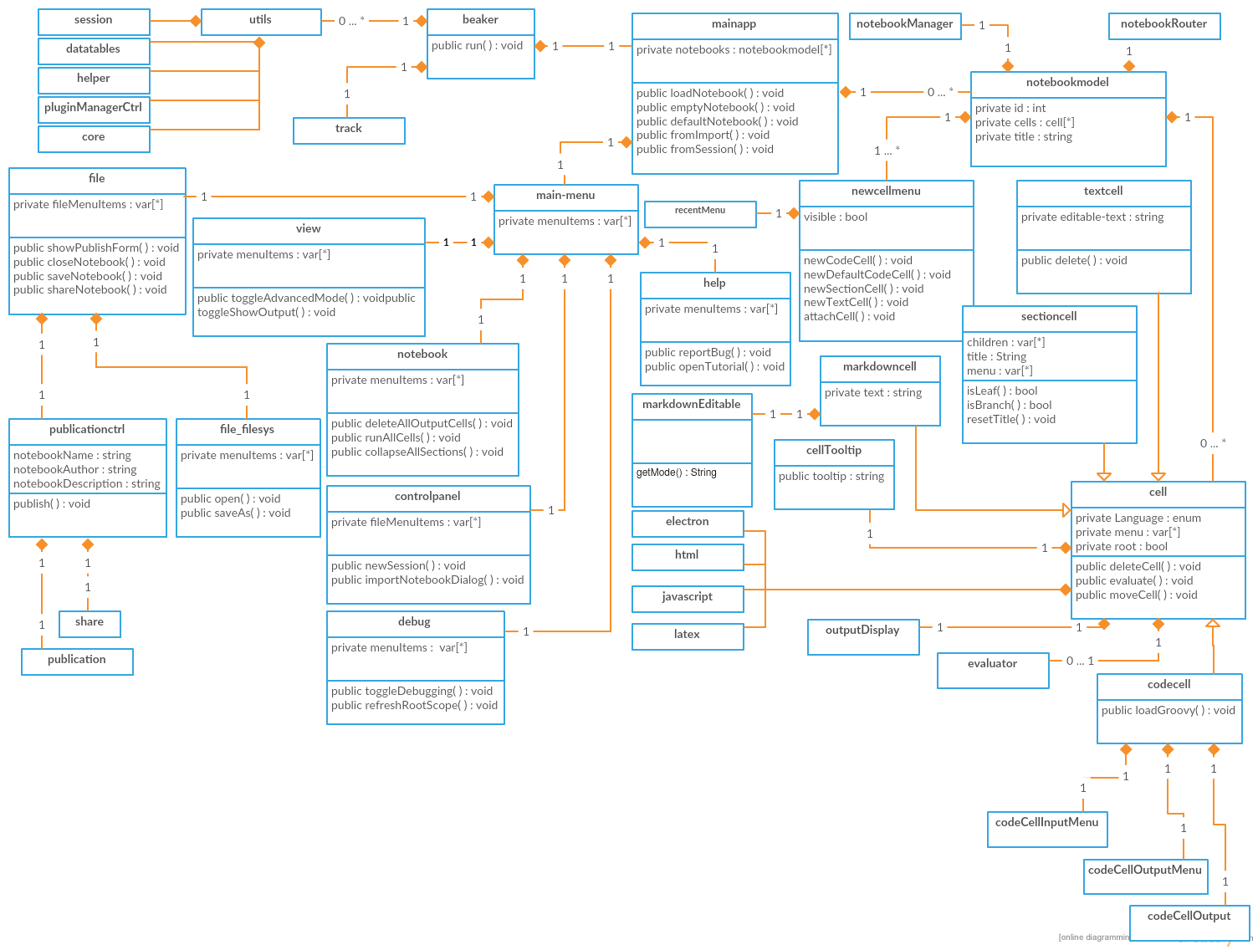

**Modified Communication Diagrams**

**Use Case 1 - New Previous Cell**

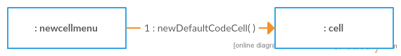

**Use Case 2 - Create New Empty Workbook**

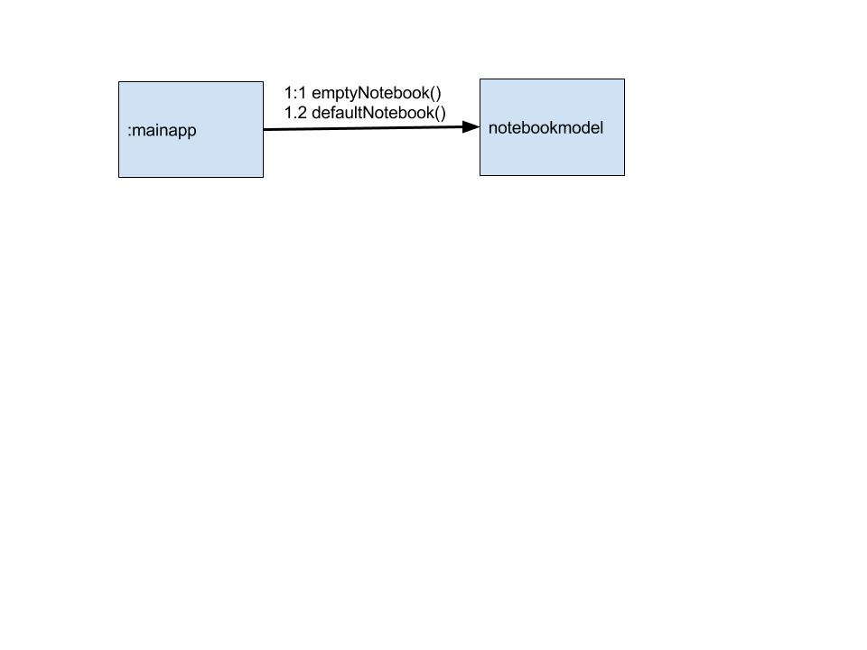

**Use Case 3 - Report Bug**

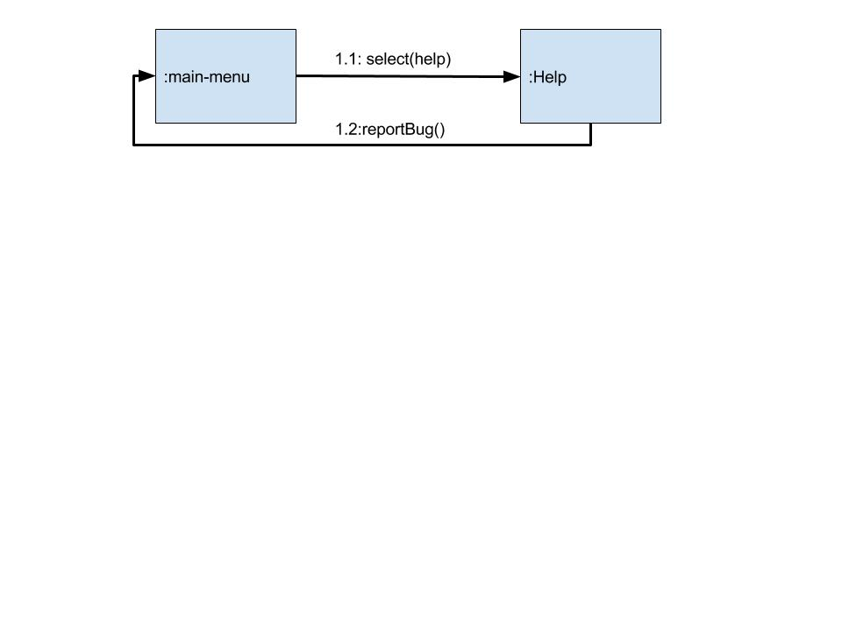

**Use Case 4 - Switch to Advanced View**

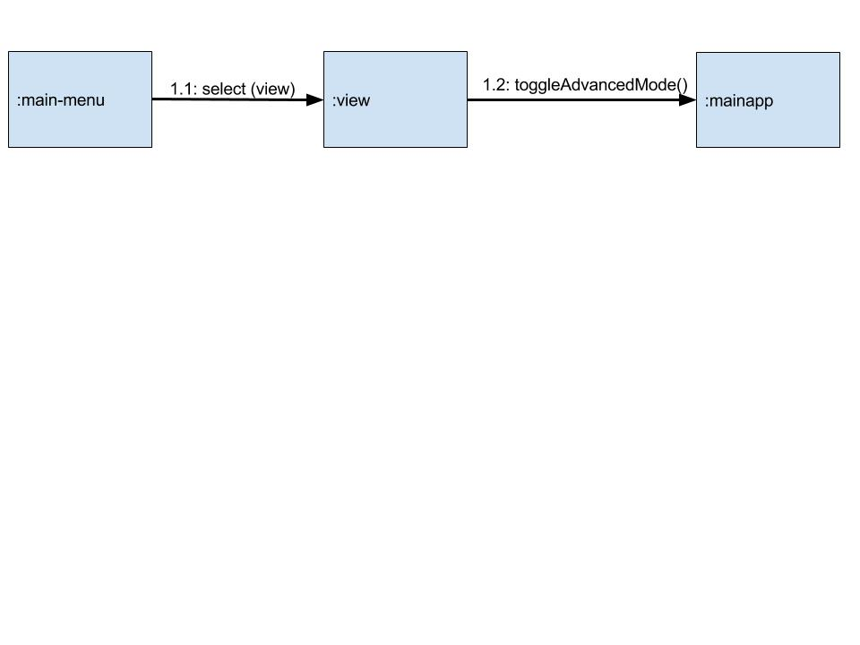

**Use Case 5 - New Cell**

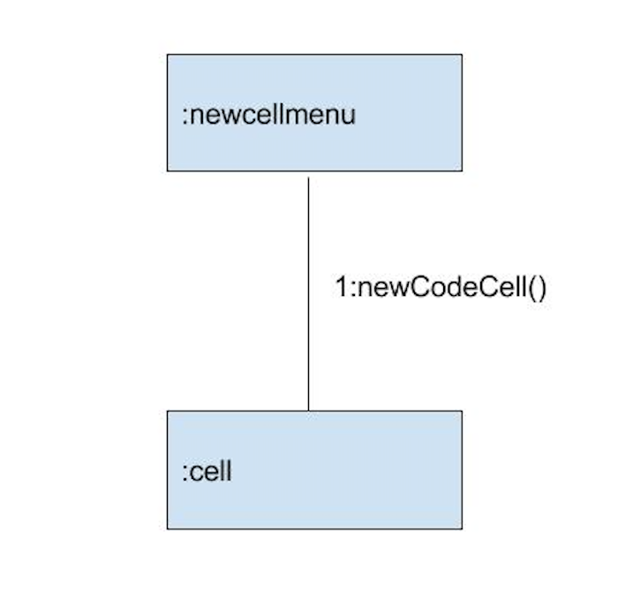

**Use Case 6 - New Textbox**

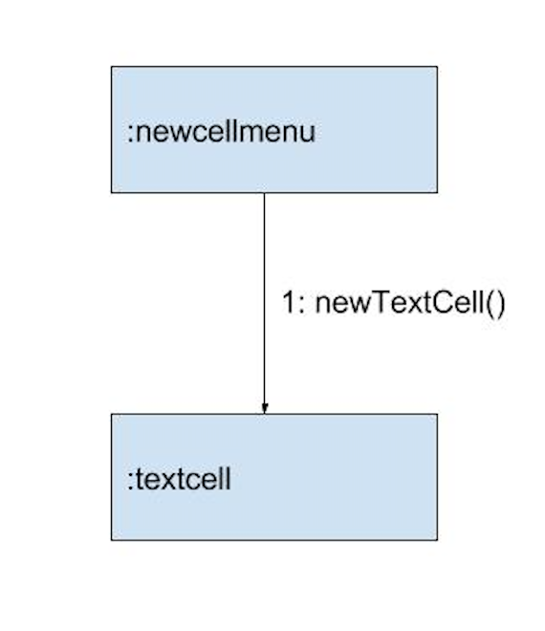

**Use Case 7 - Run Cell**

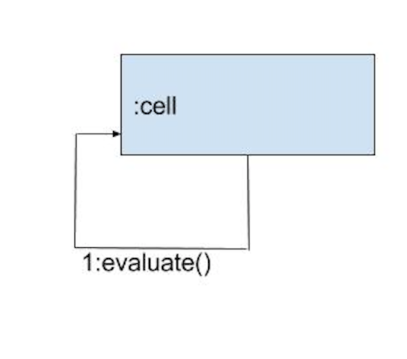

**Use Case 8 - Open Javascript Tutorial**

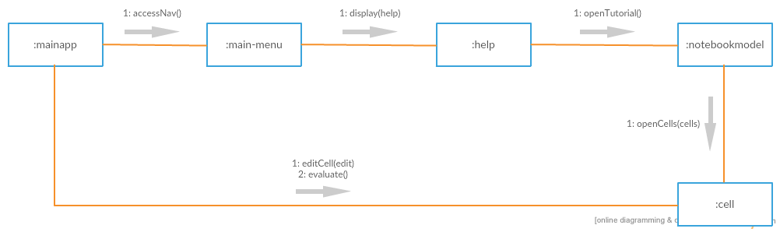

**Use Case 9 - Upload File**

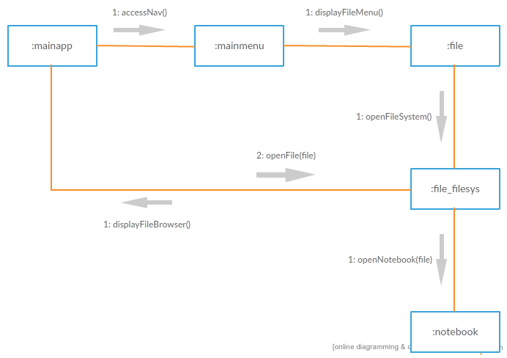

**Use Case 10 - Publish**

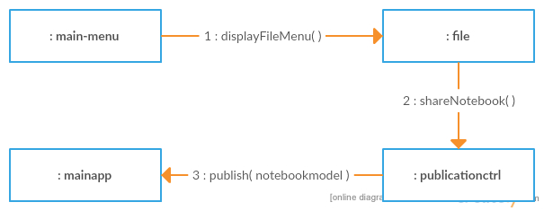

**Use Case 11 - Delete Cell**

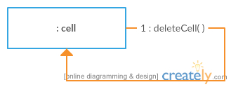

**Use Case 12 - Save Notebook**

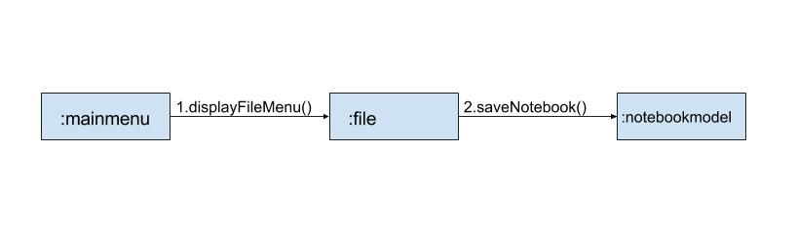

**Use Case 13 - Create Sections**

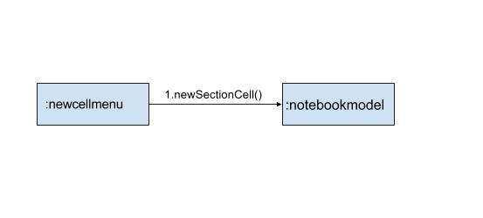

**Use Case 14 - Run All Cells**

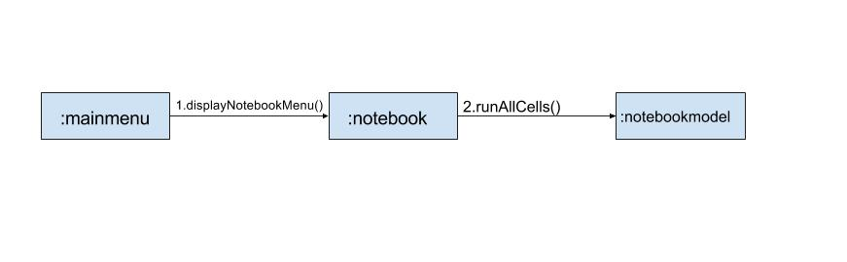

**Updated Class Table**

|  |  |  |
| --- | --- | --- |
| **Class** | **Relation with Design** | **Related To** |
| beaker | Main class of the software | mainapp, core, evaluatePluginManager, helper, utils, publication, electron |
| mainapp | Does not exist in our design; we may not have considered it because it is simply a shell that houses all of the other components | beaker,  main-menu,  Notebookmodel, utils |
| core | Does not exist in our design; we may not have considered it because we did not take into account manager classes | menupluginmanager,  utils, recentMenu, electron, commonui |
| menupluginmanager | Does not exist in our design; we may not have considered it because we did not take into account manager classes | core,  Cellmenupluginmanager, utils |
| cellmenupluginmanager | Does not exist in our design; we may not have considered it because we did not take into account manager classes | core,  menupluginmanager |
| notebookmodel | Matches Notebook in our OO design | mainapp,  cell,  textcell,  sectioncell,  newcellmenu |
| main-menu | Matches NavigationBar in our OO design | notebookmodel |
| cell | Matches Cell in our OO design | notebookmodel |
| textcell | Matches Textbox in our OO design | notebookmodel |
| sectioncell | Matches Section in our OO design | notebookmodel |
| newcellmenu | Matches ActionBar in our OO design | notebookmodel |
| file | Matches FileMenu in our OO design | main-menu,  publicationctrl,  file_filesys |
| debug | Does not exist in our design; we may not have considered it because the Debug menu was not used in our chosen use cases | Main-menu, evaluateJobManager, cellMenuPluginManager, sessionManager, coreManager, session |
| controlpanel | Does not exist in our design; we may not have considered it because the Control Panel menu was not used in our chosen use cases | main-menu,  controlpanel-directive,  controlpanelsessionitem-directive |
| controlpanel-directive | Does not exist in our design; we may not have considered it because the Control Panel menu was not used in our chosen use cases | main-menu,  controlpanel,  controlpanelsessionitem-directive |
| controlpanelsessionitem-directive | Does not exist in our design; we may not have considered it because the Control Panel menu was not used in our chosen use cases | main-menu,  controlpanel,  controlpanel-directive |
| notebook | Matches NotebookMenu in our OO design | main-menu |
| view | Matches ViewMenu in our OO design | main-menu |
| help | Matches HelpMenu in our OO design | main-menu |
| publicationctrl | Matches PublishDialog in our OO design | file |
| file_filesys | This is a utility class that doesn't exist in our implementation because its utility may only have been felt when realizing class FileMenu | file |
| pluginManagerCtrl | Does not exist in our design; we did not consider plugin implementation | coreManager, sessionManager, menuPluginManager,  evaluatePluginManager, evaluatorManager |
| notebookRouter | Does not exist in our design; we did not include classes that controlled routes |  |
| cellTooltip | Does not exist in our design; it was encompassed within our Cell class | cell |
| codeCell | Does not exist in our design; it was encompassed within our Cell class | evaluatorManager |
| codeCellInputMenu | Does not exist in our design; it was encompassed within our Cell class | coreManager, evaluatorManager, evaluateJobManager |
| codeCellOutput | Does not exist in our design; it was encompassed within our Cell class | utils, outputDisplayFactory, |
| codeCellOutputMenu | Does not exist in our design; it was encompassed within our Cell class | utils |
| markdownEditable | Does not exist in our design; it was encompassed within our Cell class | sessionManager, helper, coreManager |
| markdownCell | Does not exist in our design; it was encompassed within our Cell class | sessionManager, helper, coreManager |
| outputDisplay | Does not exist in our design; it was encompassed within our Cell class | outputDisplyFactory, utils |
| outputDisplayFactory | Does not exist in our design; it was encompassed within our Cell class | helper |
| outputDisplayServiceManager | Does not exist in our design; it was encompassed within our Cell class | sessionManager |
| pluginManagerEvaluatorSettings | Does not exist within or design, it was encompassed in our Notebook class | sessionManager |
| evaluateJobManager | Does not exist in our design; it was encompassed within our Cell class | utils, evaluatorManager |
| evaluatorManager | Does not exist in our design; it was encompassed within our Cell class | utils, evaluatePluginManager |
| notebookCellModelManager | Does not exist within or design, it was encompassed in our Notebook class | notebookmodel |
| notebookManager | Does not exist within or design, it was encompassed in our Notebook class | notebookmodel |
| notebookNamespaceModelManager | Does not exist within or design, it was encompassed in our Notebook class | notebookmodel |
| sessionManager | Does not exist within or design, it was encompassed in our Beaker class | utils, session, notebookManager, notebookNamespaceModelManager, evaluatorManager, recentMenu, electron |
| cellMenuPluginManager | Does not exist in our design; it was encompassed within our Cell class | utils |
| coreManager | Does not exist within or design, it was encompassed in our Beaker class | utils, recentMenu, notebookModelManager, electron, modalDialogOp |
| datatables | Does not exist within or design, it was encompassed in our Notebook class | utils |
| evaluatePluginManager | Does not exist within or design, it was encompassed in our Beaker class | mainapp |
| helper | Does not exist within or design, it was encompassed in our Beaker class | utils, coremanager, election |
| menuPluginManager | Does not exist within or design, it was encompassed in our Beaker class | mainapp |
| electron | Does not exist in our design; it evaluates electron code and was assumed in our Cell class | cell |
| html | Does not exist in our design; logic to evaluate html code and was assumed in our Cell class | cell |
| javaScript | Does not exist in our design; logic to evaluate JavaScript and was assumed in our Cell class | cell |
| latex | Does not exist in our design; it evaluates latex code | cell |
| utils | Does not exist in our design; it holds general utilities that has no effect to DOM directly | commonUtils,  track |
| track | Does not exist in our design; it owns the service that can be configured to 3rd party provided usage metric  logging services | beaker |
| share | Does not exist in our design; it contains the bkShare service which communicates with the backend to create shareable content and returns URL of the shard content | publicationctrl |
| session | Does not exist within or design, it was encompassed in our Beaker class | utils, sessionManager |
| recentMenu | Does not exist within or design, it was encompassed in our ActionBar class | newcellmenu |
| publication | Does not exist within or design, it was encompassed in our PublishDialog class | publicationCtrl |
| outputlog | Does not exist in our design; it was encompassed within our Cell class | utils |
| notebookVersionManager | Does not exist within or design, it was encompassed in our Notebook class | sectioncell, cell, notebook |

**Reports**

**Classes Missing From Design**

beaker - “The root of everything”

mainapp - This is Beaker’s shell, holding active Notebooks and the Main Menu

core - All view-managers use core as a communication service

menupluginmanager - Manages menu items

cellmenupluginmanager - Manages cell items

debug - This is the Debug dropdown menu on the Main Menu

controlpanel - This is the Control Panel dropdown on the Main Menu

controlpanel-directive - Module for control panel section

controlpanelsessionitem-directive - Sets up control panel sessions

file_filesys - This adds file system specific menu items to the File Menu

pluginManagerCtrl - Module that shows the list of evaluators with their settings panel

notebookRouter - Routes notebook to the server

cellTooltip - Displays the appropriate tooltip for the cell

codeCell - The part of the cell that you type code into

codeCellInputMenu - The right click menu of the cell

codeCellOutput - The output of the given cell

codeCellOutputMenu - The menu provided for the cell output

markdownEditable - Editable markdown cell

markdownCell - A cell of markdown value

outputDisplay - The display of cell evaluation output

outputDisplayFactory - The “machine” that displays cell output

outputDisplayServiceManager - The service manager of output display

pluginManagerEvaluatorSettings - The manager for plugin evaluation

evaluateJobManager - Manager for altering job evaluators

evaluatorManager - Manager for altering evaluators

notebookCellModelManager - Manipulates a notebook’s code cells

notebookManager - Manages notebook properties

notebookNamespaceModelManager - Manages namespace models

sessionManager - Manages connection sessions

cellMenuPluginManager - Manager of cell menu plugins

coreManager - Manages core properties of beaker

datatables - Editable data tables

evaluatePluginManager - Evaluates plugins for beaker

Helper - Standard helper for beaker utils

menuPluginManager - Manages menu plugins

Electron - Evaluator for electron code

html - Evaluator for HTML code

javaScript - evaluator for js code

latex - evaluator for latex code

utils - Core utilities package

track - Tracks server-beaker stats

share - Communicates with backend service to create shareable content

session - Service which backs up a session

recentMenu - Service which retrieves recent menu items and updates the recent menu

publication - Publication API wrapper

outputlog - Service which gets output log from the server

notebookVersionManager - Utilities to convert old versions of notebook to the latest

**Extra Classes In Design**

LandingPage - Instead of being its own class, this is housed by mainapp

**Adjusted Classes**

FileMenu - Renamed to “file”

ViewMenu - Renamed to “view”

NotebookMenu - Renamed to “notebook”

HelpMenu - Renamed to “help”

PublishDialog - Renamed to “publicationctrl”

Notebook - Renamed to “notebookmodel”

NavigationBar - Renamed to “main-menu”

Section - Renamed to “sectioncell”

Textbox - Renamed to “textcell”

ActionBar - Renamed to “newcellmenu”

Cell - Renamed to “cell”

**Com S 362 — Object-Oriented Analysis and Design**

**Certification of Individual Contribution and Understanding Form**

Project Name: Design to Code Traceability II Team Facilitator: Christian Klein

Homework Set: Studio #10 Date: 11-14-2016

Directions: Enter each team member’s name, and a “work rating” (1 - 5 with 5 as high and 1 as low score) that corresponds to the relative share of work done by the team member. Comments to explain work ratings other than 3 must also be provided. The total of the ratings must add up to 3 times the number of team members. Each team member must sign at the end of the form showing your agreement to your team member’s contribution.

|  |  |  |  |
| --- | --- | --- | --- |
| Printed team member’s name | Work  Rating  (1 - 5) | Comments/Explanations | Understanding  Self Rating  (0 to 100%) |
| Christian Klein | 3.5 | Modified Class Diagram  Updated Class Table  Use Cases: 1, 10, 11  Reports | 90% |
| Derek Yu | 3.5 | Modified Class Diagram  Updated Class Table  Use Cases: 2, 3, 4  Reports | 90% |
| Jay Patel | 1 | Use Cases: 5, 6, 7 | 90% |
| Joe Thill | 4 | Java Class Diagram  Java Table  Use Cases: 8, 9  Reports | 90% |
| Zifeng Jiang | 3 | Updated Class Table  Use Cases: 12, 13, 14  Reports | 90% |
| Total: | 15 |  | |

Note that you must make Total = 3 * (Number of team members)

|  |  |
| --- | --- |
| I agree to the above ratings and understand our team’s solution. | |
| Christian Klein | Joe Thill |
| Derek Yu | Zifeng Jiang |
| Jay Patel |  |